***Knowledge discovery and management***

***Report on Project Increment-1***

**By: Bathina, L V Sandeep  
Shah, Vidhi Jagdishchandra  
Rama krishna Tammabathula**

The Goal of this project is to develop a Disease Management system to give users the information either the demographics or the statistics of the diseases along with the hospital information available in the area. Thus giving a chance for the better analysis and reducing in the health care expenditure.

For achieving this goal, in the first increment of the project we created:

* User Login page
* Search with auto complete Using Solr

**Architecture Diagram:**

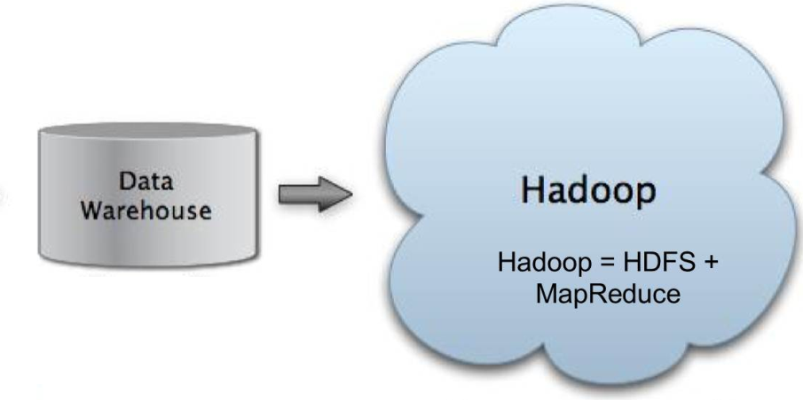

Lucene Index

Solar search

User

Following the above approach, we stored our data in Hadoop and applied the Lucene indexing on the data which is interfaced with Solr for full text searching. Output of Solr search is displayed on application which user operates.

**User interface:**

Screenshot of the registration page for the user:

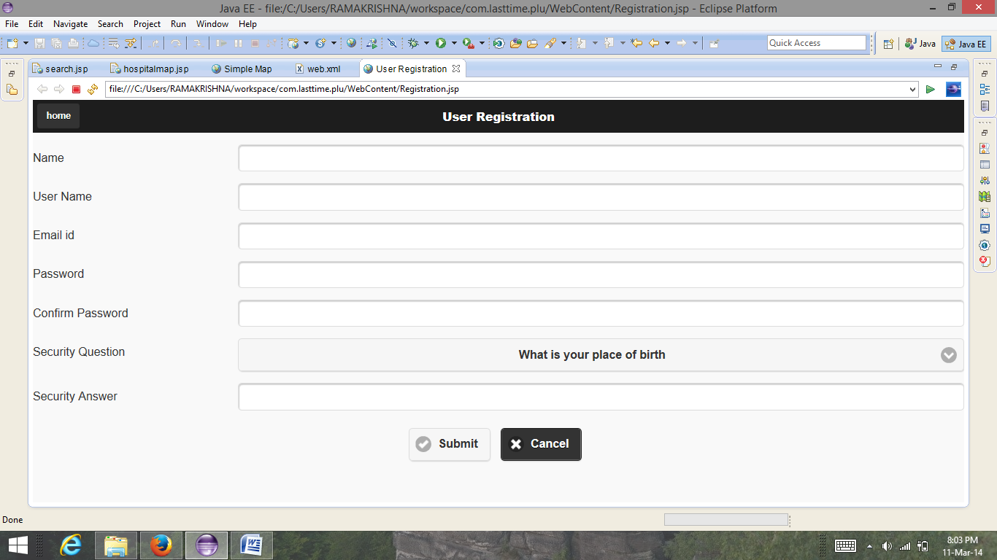

Screenshot of Sign in page:

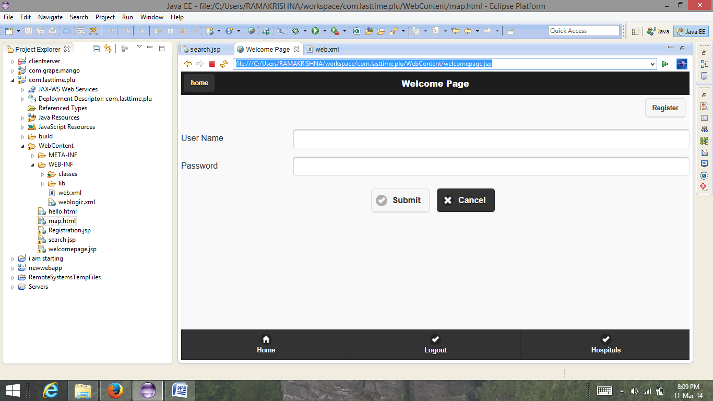

This is the main page of the application and It returns the results that are obtained using the solr and it also has the link to the map containing hospitals list.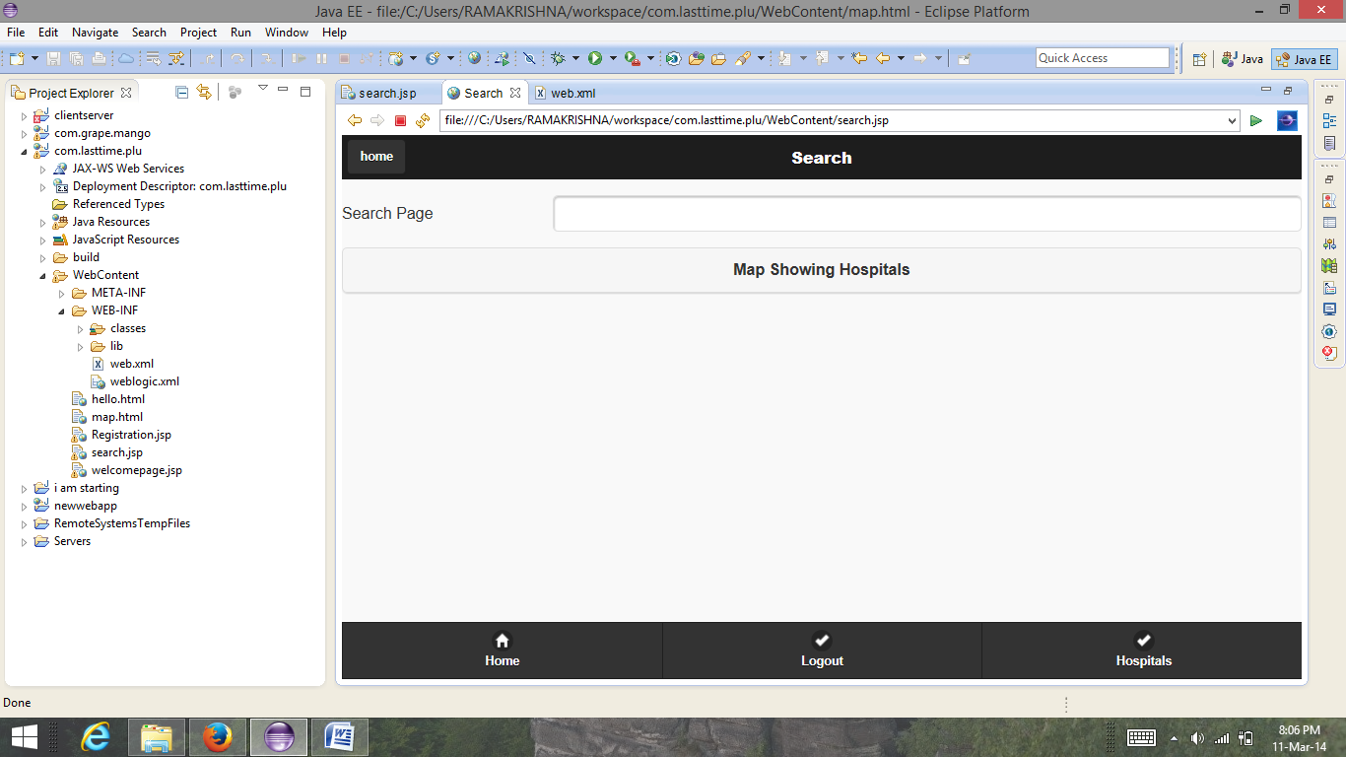

The map showing the hospitals in the given location. We made this map as our project is location based.

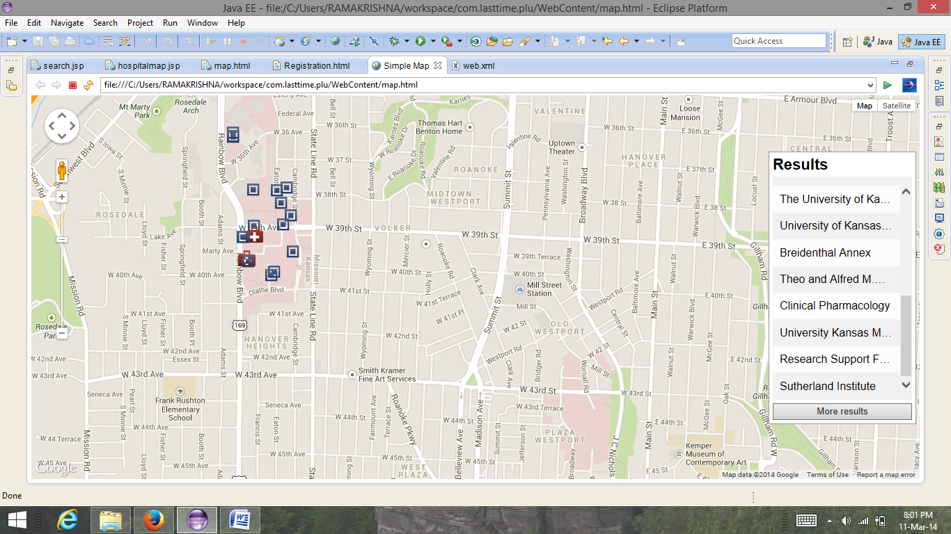

Screenshots of lucene indexing:

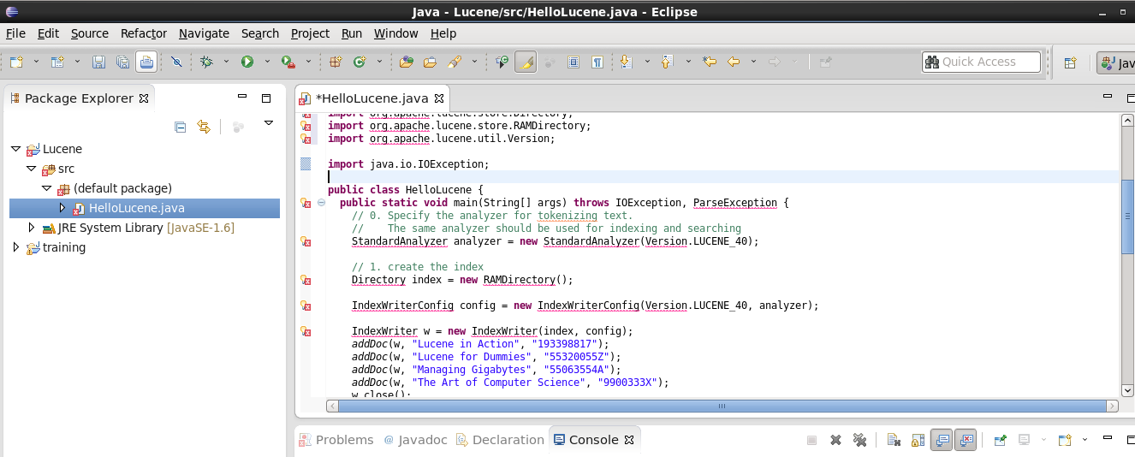

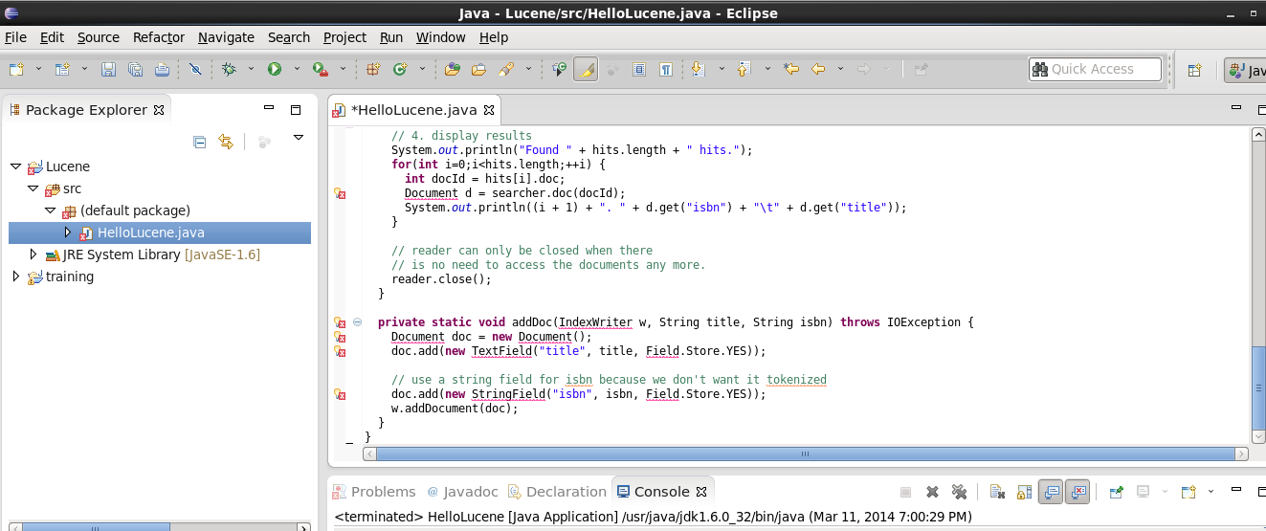

Error:

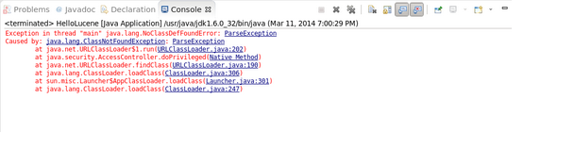

Solr:

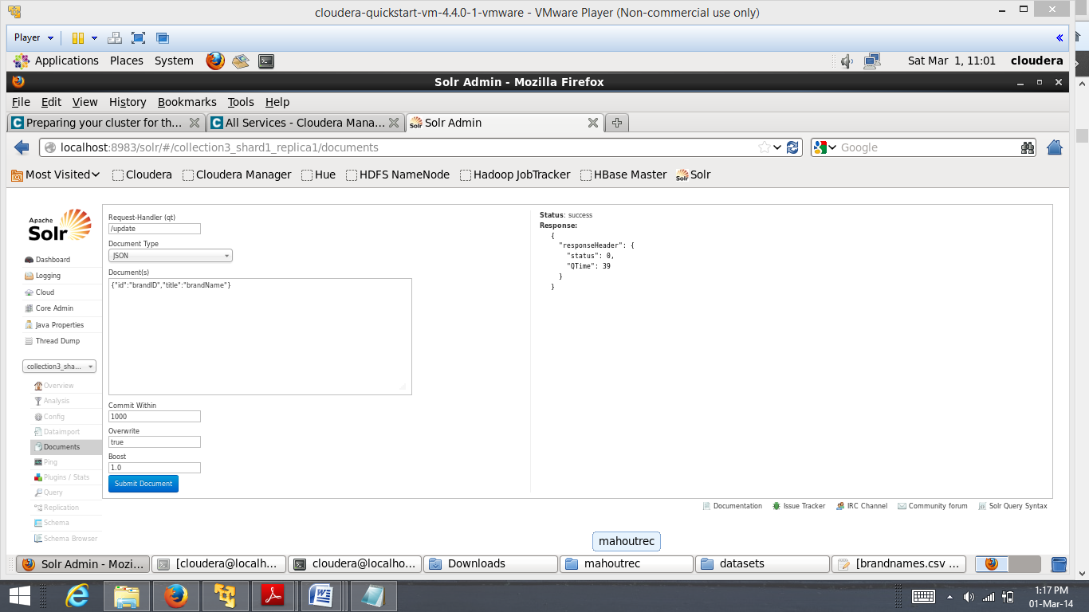

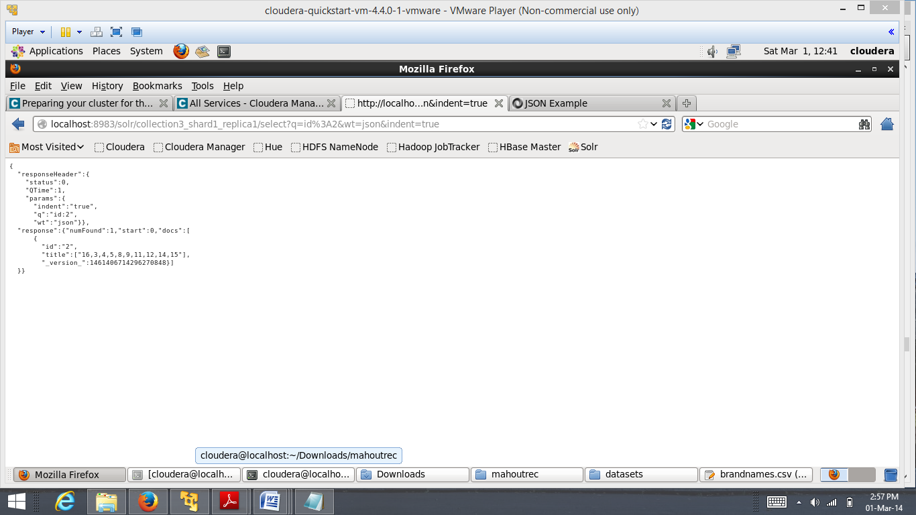

**Domain Model:**

1. **Data sources:**

* <https://data.medicare.gov/Physician-Compare/National-Downloadable-File-Extended-View/3uxj-hea6>
* <https://data.medicare.gov/data/medicare-s-helpful-contacts>
* <https://data.medicare.gov/data/home-health-compare>

1. **Algorithm:** It will be used in the upcoming increments.
2. **Analytical tool:** Lucene Index

**Application Specification:**

1. **Web services** **:** RESTful API
2. **Programming languages :** JAVA
3. **Front end:**   JQuery Mobile, HTML 5,Android
4. **Hadoop distribution :** Cloudera
5. **Machine Learning tool :** Mahout
6. **Searching tool :** solr, lucene

**Design of mobile client:** we are using JQuery for front end.

**Implementation:** We made mobile application and stored data in hadoop and applied lucene indexing on the data for searching process.

**Project management:**

Team Involvement:

1. User Interface and map API done by RamaKrishna
2. Lucene Indexing on the given data done by Sandeep BLV
3. Solar Indexing and searching done by Vidhishah.

Collecting data sets is done by the whole team.

In the second increment, we are going to work on the following :

* Grouping the diseases using solr
* Searching for symptoms from the text files